PowerVN4-AHDM

Specification

Purpose
PowerVN8-AHDM is an electronic module that is running the VideoNet® system and designed to:
  - receiving video signals from the digital high-definition cameras with analog signal transmission (AHDM) and the subsequent processing of video signals in the VideoNet® environment;
  - receiving the audio signal, its digitization and processing in the VideoNet® environment.

Тechnical features
Number of connected video cameras: 4
Number of linear audio inputs: 4 (8bit/8KHz)
Maximum frame rate: 100 fps
Connector type for connection to a computer: PCI Express х1
Type of connector for video and audio signals: DHS-15 F
Power supply (power is supplied to the card via the PCI Express x1 connector): + 3,3 V
Consumption current: no more than 0.8 A
Overall dimensions: 120x100x25 mm
Weight: 90 г.

Operating conditions
Ambient temperature: +5… +50°С
Relative air humidity at Т +20°С: not more than 80 %
Standard video signal: analog high definition system (AHD)
Standard audio signal: typical 0.5 V, maximum 1 V.

Installation and connection
PowerVN4-AHDM video/audio capture board must be installed into the PCI Express х1/x4/х8/х16 slot of motherboard of your computer.
To connect video and audio sources to the PowerVN4-AHDM board, use the cable splitter included with the PowerVN4- AHDM board, see Fig. 2. The pin numbers of the BNC connectors on the splitter correspond to the camera numbers in the VideoNet® system.
Connector 2 of the splitter (see Figure 2) is connected to the connector 1 of the PowerVN4-AHDM board (see Figure 1).
Drivers for the video/audio capture board are located on the VideoNet® installation DVD.

Attention!
Using third-party drivers for this video/audio capture board is not allowed.

Note:
Before you start installing drivers, you need to make sure that there are no third-party drivers for the video/audio capture boards on the computer, otherwise an incorrect installation may be possible, resulting in the inoperability of the operating system.

Connector 1 - connector for video and audio signals

Fig. 1. PowerVN4-AHDM board connectors location

2
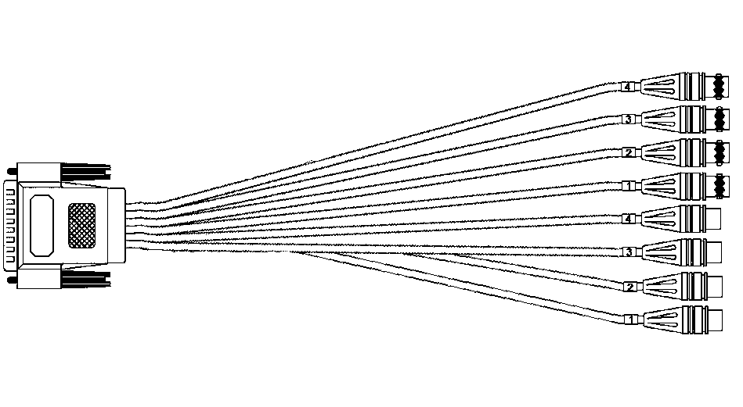
Fig. 2. Cable splitter

Package contents
- PowerVN8-AHDM board | 1 pc.
- Specification | 1 pc.
- Cable splitter | 1 pc.
- Packing (antistatic) | 1 pc.

Manufacturer’s warranty
Manufacturing Company SKYROS Corporation provides warranty of the product for 12 months from the date of sale. In case of the absence of a mark of release – warranty period is calculated from the date of manufacture of the product.
This warranty is void if the PowerVN8-HD board is out of order in case of:
• wrong connection;
• non-compliance with this guide;
• mechanical damage;
• disaster;
• signals that exceed standard values.
The manufacturer has the right to make changes in design of product, without affecting its basic technical parameters.
All questions of warranty and post-warranty repair, contact: 17, Remeslennaya st., St.Petersburg, Russia, tel. +7 (812) 448-10-02.

Certificate of acceptance
The PowerVN4-AHDM board (serial number _______________) meets the specifications and is suitable for operation.

Release date | __.__.__ | QCD stamp

The mark of realization (sale)

Date of sale
(DD/MM/YY)

Seller
 |  | (signature) |  | (Full name)

stamp

